30. [Created Here](https://drive.google.com/drive/folders/1ieEGUre58D_3Sebbz3Bazh1LLX0uowPd?usp=sharing)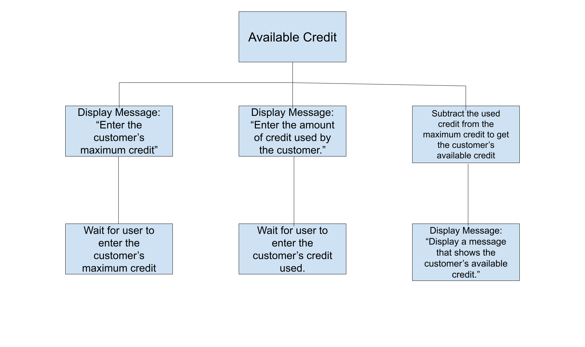

31. [Create Here](https://drive.google.com/drive/folders/1ieEGUre58D_3Sebbz3Bazh1LLX0uowPd?usp=sharing)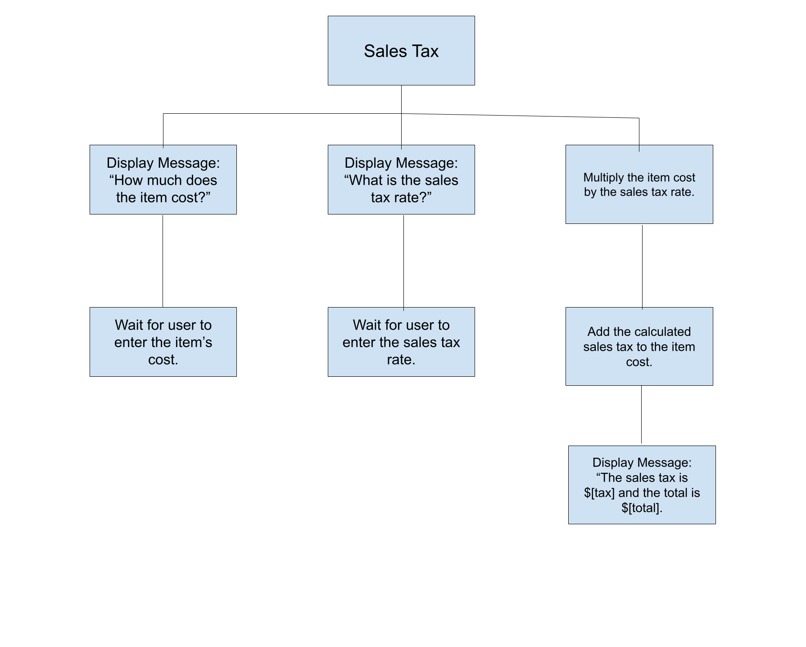

32. [Created Here](https://drive.google.com/drive/folders/1ieEGUre58D_3Sebbz3Bazh1LLX0uowPd?usp=sharing)

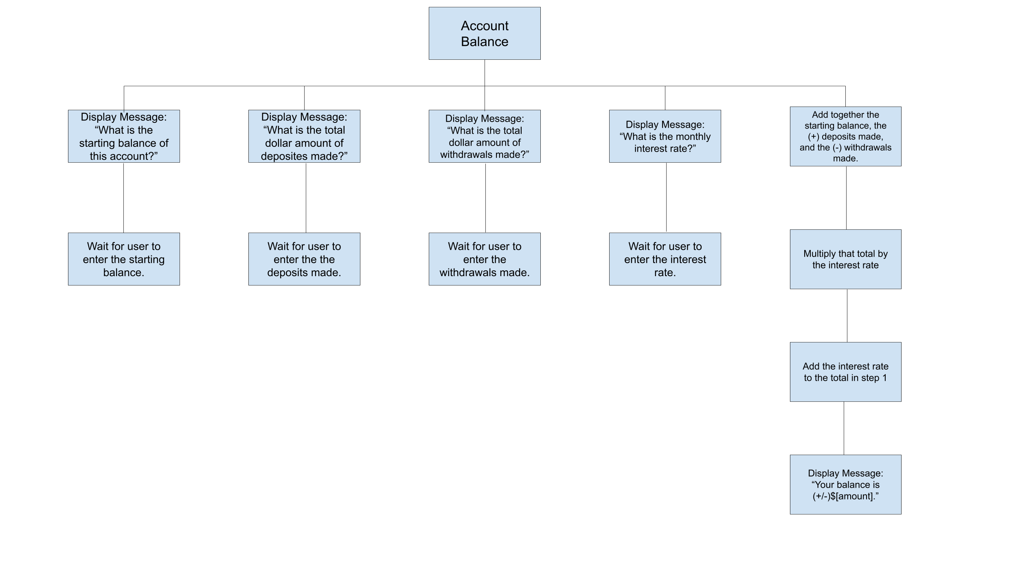

33. [33.cpp file here](https://github.com/kalebe2/Class-Assignments/tree/main/Chapter%201)

|  |
| --- |
| #include <iostream>  using namespace std;  int main() {  int x = 0;  int y = 5;  x = x+1;  y = y+1;  y = x+y  cout << y;  } |

34. [34.cpp file here](https://github.com/kalebe2/Class-Assignments/tree/main/Chapter%201)

|  |
| --- |
| include <iostream>  using namespace std;  int main() {  int j = 10;  int k = 2;  int l = 4;  j = j*k;  l = k*l;  k = j+l;  cout << k;  } |

35. [35.cpp file here](https://github.com/kalebe2/Class-Assignments/tree/main/Chapter%201)

|  |
| --- |
| include <iostream>  using namespace std;  int main() {  int a = 1;  int b = 10;  int c = 100;  int x = 0;  x = c*3;  x = b*6 + x;  x = a*5 + x;  cout << x;  } |

36. The issue with this code is that it didn’t calculate the area before it displayed the result. It should look like this:

|  |
| --- |
| Display “What is the room’s width?”.  Input width.  Display “What is the room’s length?”.  Input length.  Multiply width * length to get area.  Display area. |